**EXPERIMENT 2**

**Aim:** Verification of Kirchhoff’s Current Law and Kirchhoff’s Voltage Law for electric circuit. **Apparatus:** DC Power Supply, Ammeter (0-1A), Voltmeter (0-150V), Rheostats, Multimeter **Circuit Diagram:**

**15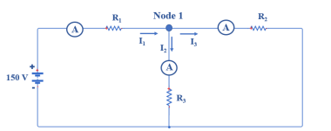6 V** Fig 1. Resistive Circuit for Kirchhoff’s Current Law

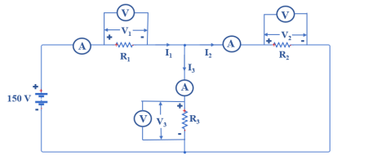**156 V**Fig 2. Resistive Circuit for Kirchhoff’s Voltage Law

**Brief Theory:**

**Procedure:**

**(A)To verify Kirchhoff’s Circuit Law:**

1) Connect the circuit as shown in the Fig.1.

2) Set the values of rheostats to R1=145Ω and R2=300 Ω and R3=145Ω 3) Connect ammeter in series with each resistor.

4) Turn ON the DC power supply, measure the supply given to circuit using Multimeter and set its value to 156V.

5) Observe the current shown in each ammeter and note it down.

6) Using Equ.1 verify Kirchhoff’s Current Law.

**(B) To verify Kirchhoff’s Voltage Law:**

1) Connect the circuit as shown in the Fig.2.

2) Set the values of rheostats to R1=145Ω and R2=300 Ω and R3=145Ω

3) Connect Voltmeter in parallel with each resistor.

4) Turn ON the DC power supply, measure the supply given to circuit using Multimeter and set its value to 156V.

5) Observe the current shown in each voltmeter and note it down.

6) Using Eq.2 verify Kirchhoff’s Voltage Law.

**Observation Table1 for KCL:**

R1=145Ω, R2=300 Ω, R3=145Ω and V = 156volts

|  |  |  |
| --- | --- | --- |
| **Current through Resistors** | **Observed Values** | **Calculated Values** |
| **I1** | 0.65 A |  |
| **I2** | 0.21 A |  |
| **I3** | 0.45 A |  |

**Observation Table2 for KVL:**

R1=145Ω, R2=300 Ω, R3=145Ω and V = 156volts

|  |  |  |
| --- | --- | --- |
| **Voltage across**  **Resistors** | **Observed Values** | **Calculated Values** |
| **V1** | 93 V |  |
| **V2** | 62 V |  |
| **V3** | 62 V |  |

**Calculations:**

**Questions:**

1) For a resistive circuit as shown in Fig.1 with 150Volts DC supply, R1 = 100Ω and R2 = 200Ω and R3 = 150Ω. Calculate the current flowing through each resistor and verify KCL at Node 1.

2) For a resistive circuit as shown in Fig.2 with 150Volts DC supply, R1 = 100Ω and R2 = 200Ω and R3 = 150Ω. Calculate the voltage across each resistor and verify KVL.

**Results:**

**Conclusion:**